Influence of coarse additions on the plasticity and toughness of soil mixtures, Part II: Effect of sand angularity and sand size uniformity.

last compiled Wed. 2022-06-01, 6:37 PM

# Abstract

The Atterberg limits may offer a useful means to evaluate baseball infield soils because they quantitatively relate soil behavior to water content. Prior research has demonstrated that liquid and plastic limits (LL and PL) of sand-clay mixtures are affected by the quantity and type of admixed sand, but these studies have used sand exclusively <425 μm and little attention has been devoted to sand angularity and sand-size uniformity.

This research was conducted to clarify the effect of sand angularity and sand-size uniformity on the Atterberg limits of soil mixtures containing a range of sand contents and a significant mass percentage 425-2000 μm.

Experiment 1 compared the effect of mixing either an angular or a round sand (both 0.5-1 mm) with a kaolinitic clay at sand contents between 0 and 80%. Little difference was observed in LL and PL, suggesting angularity plays a minimal role on mix performance.

Experiment 2 compared the effect of mixing one of two sands having similar D50 (0.42 and 0.49 mm) but varying uniformity (uniformity coefficients of 1.9 vs. 3.9) with an illitic clay at sand content 0-80%. Mixtures including the high-Cu sand maintained their plasticity to higher sand content (~72.5%) than those produced with the low-Cu sand (~67.5%).

Calculations for the threshold fines content (TFC) and intergranular porosity agreed closely with the experiments, indicating a potential to estimate TFC from sand porosity alone.

# Introduction

The Atterberg limits are used by geotechnical engineers to classify fine-grained soils (ASTM International, 2017). These tests include the liquid limit (LL) and plastic limit (PL). The tests were developed for fine-grained soils, but research has shown the amount and properties of admixed sand also affects the test results (Atterberg, 1911; Dumbleton and West, 1966; Sivapullaiah and Sridharan, 1985; Barnes, 2013). Particle angularity and particle-size uniformity are known to affect the behavior of granular materials, but their effects are less clear for soils which contain significant amounts of fines (Mitchell and Soga, 1993; Hojae and McNitt, 2001; Holtz et al., 2010; Miller and Henderson, 2011; Zuo and Baudet, 2015).

## Atterberg limits of soils having varied sand angularity

Particle angularity is defined as the roughness of a particle surface (Brady and Weil, 2007). Mathematical definitions have been used to quantify angularity, although it is often estimated using representative charts developed from the metrics (Wadell, 1932; Krumbein, 1941; Suhr et al., 2020).

Research on the importance of sand angularity in soil mixtures has produced mixed results. Dumbleton and West (1966) tested mixtures of various types of coarse particles with either kaolinite or montmorillonite. Dumbleton and West (1966) demonstrated that mixtures including angular sand had higher LL and PL relative to mixtures produced with equivalent amounts of glass spheres. The researchers postulated that angular particles had more surface area compared to the spheres, requiring additional water to coat their surfaces before they could slide or flow past one another.

Findings by Sivapullaiah and Sridharan (1985) differ from those of Dumbleton and West (1966). Sivapullaiah and Sridharan (1985) mixed either angular or round particles of the same size fraction (150 μm – 75 μm) with bentonite clay at sand contents ranging from 20-95 %. Sivapullaiah and Sridharan (1985) reported no difference in the liquid or plastic limits due to angularity.

## Atterberg limits of soils having varied sand uniformity

Particle-size uniformity, or more simply “uniformity,” is defined as the similarity of diameters across particles within a soil. The coefficient of uniformity (Cu) is a commonly used mathematical definition (Adams and Gibbs, 1994; Holtz et al., 2010). Cu is the ratio between the particle diameters at which 60% and 10% of the sample is finer:

Little research is available on the effect of sand uniformity on the Atterberg limits of soil mixtures. This is probably because the upper boundary of allowed particle sizes in ASTM D4318 (425 μm) limits the total range of sand particle diameters. Dumbleton and West (1966) reported that mixes produced using non-uniform sand had similar Atterberg limits to mixes containing sand from a single mesh size. However, all of the sand in their experiment was between 425 and 53 μm, limiting the potential variability in uniformity. Efficient particle packing - defined as the ability of smaller particles to fit comfortably in the voids between larger particles - is limited when the majority of particle diameters fall within a factor of 10 (Lade et al., 1998). It is possible that a larger uniformity effect on LL and PL would be observed if coarser sand were included in the mixture to create a higher Cu.

At very low sand contents, angularity and uniformity are probably unimportant because the sand grains are suspended in a clay-water matrix and do play an insignificant role in transmitting loads through the soil skeleton. At higher sand contents, the coarse grains begin to contact one another and the nature of these contacts will affect the behavior of the bulk soil (Mitchell and Soga, 1993; Zuo and Baudet, 2015). As sand content continues to increase, the soil becomes nonplastic because plasticity is not observed in soils dominated by granular particles (Mitchell and Soga, 1993; Holtz et al., 2010). The behavior transition between sand-like and fines-like behavior occurs at a fines content termed the threshold fines content (TFC) (Zuo and Baudet, 2015; Sibley and Polito, 2020).

Because less-uniform sands have less total void space, one could expect these sands to require a lesser proportion of fines to fill their interstices, compared with a more uniform sand. Therefore, sand uniformity could alter the upper limit of sand content at which the soil will exhibit plasticity.

# Objectives

Recent research has demonstrated that the LL and PL tests can be performed on soils containing a significant amount of particles 2000-425 μm (Mascitti and McNitt, this issue). It is unclear what effect sand shape and uniformity play on the Atterberg limits of soil mixtures containing these coarser sands.

The present research was conducted to answer two questions:

1. How does sand particle angularity affect LL and PL of sand-clay mixtures when total sand content and sand particle size are held constant?
2. How does sand-size uniformity affect LL and PL of sand-clay mixtures when total sand content and *average* sand particle size (D50) are held constant?

# Materials and methods

Two experiments were conducted to evaluate the effects of sand angularity and uniformity on the Atterberg limits of soil mixtures containing a range of sand contents.

## Mixture component characterization

The minimum and maximum void ratios of the sand components used in each experiment were characterized using modified versions of ASTM (2011, 2016). In the minimum void ratio test , a single lift of sand was dynamically compacted using a specified drop weight. In the maximum void ratio test, the sand was carefully poured into a container of known volume and leveled with a straight edge.

The liquid and plastic limit of each clay component were determined individually using ASTM D4318 (ASTM International, 2018). The LL of the kaolinitic clay used in Experiment 1 was 43 and its PL was 17, yielding a plasticity index of 26. The PL of the illitic clay soil used in Experiment 2 was 18 and its LL was 30, yielding a PI of 12. The particle size distribution of the illitic clay soil used in Experiment 2 is also shown in Figure .

## Mixing procedure

All mixture components were air-dried and their water contents were determined gravimetrically. The clay components were pulverized and passed though 0.25 mm screen. Sands were mixed by hand with the relevant clay component until visually homogeneous. The mixture component percentages were adjusted for the trace amounts of particles 2000-53 μm in the clay components. Final mixture percentages are expressed as oven-dry mass.

## Treatments

Experiment 1 evaluated mixtures containing equivalent amounts of one of two sands having varying angularity. Two sands were selected based on their classification as angular and well-rounded. The sands were visually classified using a microscope and the chart from Baker (2006) (Figure ). Each sand was then repeatedly sieved to remove particles <0.5 mm and >1 mm. The single-mesh sands were mixed with a kaolinitic clay to yield mixtures having 0, 20, 40, 60, 70, 75, and 80 % sand.

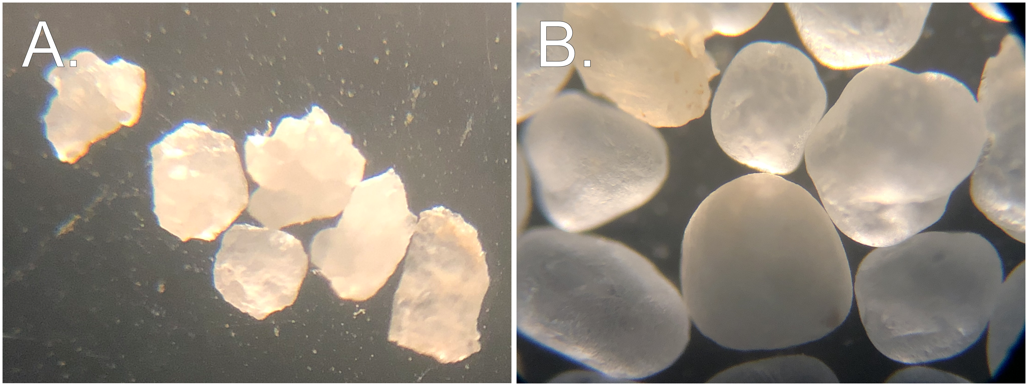

**Figure** : Angular (A.) and well-rounded (B.) sands used for Experiment 1.

Experiment 2 evaluated the effect of sand-size uniformity for mixtures containing one of two sands having similar D50 but varying Cu. The two sands were produced from a single washed concrete sand having a wide particle size distribution. The original concrete sand was sieved to remove all particles >1 mm and <0.25 mm. The remaining fraction between 1 and 0.5 mm was riffled into two aliquots. The first aliquot remained untouched and is termed the “low-Cu sand”. The second aliquot, termed the “high-Cu sand”, had a portion of the removed particles (>1 mm and <0.25 mm) returned. This procedure created a wider particle-size distribution while maintaining a similar D50. Figure shows the particle size distributions of the low-Cu and high-Cu sands. These sands meet the criteria of having similar D50 values (0.42 mm and 0.49 mm) but different Cu values (1.9 vs. 3.9). While the Cu value of 3.9 is still relatively low compared to natural alluvial sands, in this experiment the maximum obtainable Cu was limited by the maximum particle diameter of 2000 μm and the intentionally limited mass of particles <425 μm.

Each of these sands were mixed with a single illitic clay soil to yield mixtures having between 0 and 80% sand, for a total of 42 mixtures. Mixtures were produced at 5% sand content intervals between 0 and 50%, and a 2.5% interval between 50 and 80% sand. The increased spacing of data points between 50-80% sand was designed to provide better resolution near the threshold fines content.

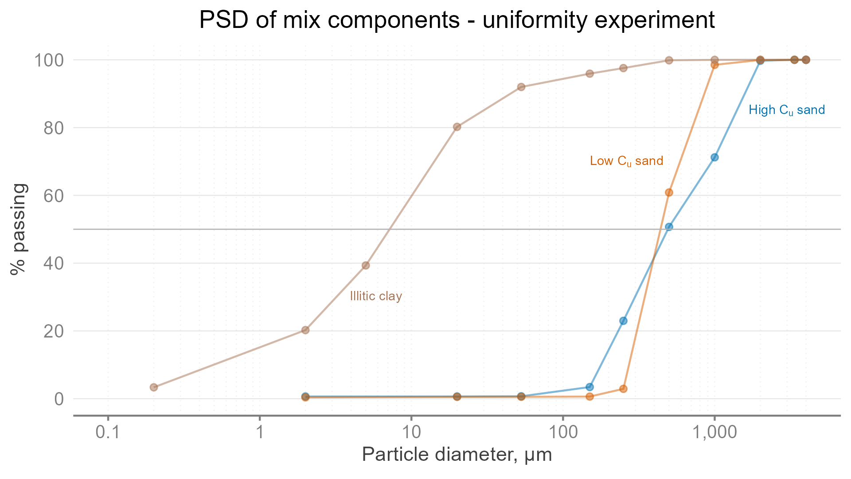

**Figure** : Particle size distributions for the two sands and one clay used in Experiment 2. Dashed grey lines indicate $D_{50}$ for each sand.

## Atterberg limit test protocol

After mixing the sand with the relevant clay component, LL and PL tests were performed on a series of mixtures to evaluate the effect of sand angularity or uniformity.

The liquid and plastic limit tests were performed according to a modified version of ASTM D4318 (ASTM International, 2018). The modification eliminated the wet-sieving procedure so particles between 2000 and 425 μm remained in the sample (Mascitti and McNitt, this issue). At least four data points were collected during the LL test in order to plot the flow curve. In the PL test, 3 threads were rolled to the crumbling condition before being weighed to ± 0.001 g and oven-dried. In both experiments the average of the 3 results was used to represent the PL of each sample.

## Statistical analysis and computational environment

LL and PL were the dependent variables in both experiments. A two-way ANOVA model was fitted to test the interaction effect between particle shape and percent sand (Table ) In Experiment 1, particle shape was considered a categorical predictor while a 2nd-order polynomial spline term was used to model percent sand as a continuous predictor. In Experiment 2, Cu was considered a categorical predictor while percent sand was treated as in Experiment 1. Main effects and interactions were tested using Type III Sums of Squares. Treatments were considered significantly different at α = 0.05.

All analyses were performed using the lm() function in the R Language for Statistical Computing (version 4.2.0) (Team, 2022). GNU Make (GNU, 2020) was used to facilitate reproducible analyses by maintaining links between raw data, analysis code, and finished output. Raw data and analysis code are included in the supplemental materials.

# Results and discussion

## Experiment 1: Effect of sand angularity

Experiment 1 compared the effect of angularity for two sands of equal size ranging from 0-80% sand. Figure shows that the LL and PL were nearly identical for sand content <60%. At sand content ≥ 60%, a very slight increase in both LL and PL is visible for the angular sand, but this increase was not statistically significant.

The maximum difference between angular and round sand for any of the tests was 1.0 % water content. Under the conditions of this study, particle angularity is not important when sand size and sand contents are held constant.

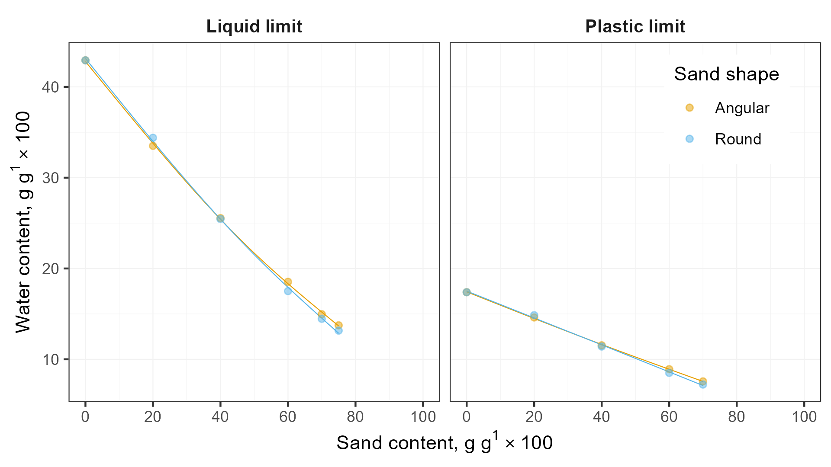

**Figure** : The effect of particle shape on both the LL and PL tests was minimal.

**Table** : Analysis of variance table for each characteristic water content in Experiment 1.

| Test type | Term | Sum Sq. | Deg. of Fr. | F-Statistic | P-value |
| --- | --- | --- | --- | --- | --- |
| LL | Intercept | 0.2102326912903 | 1 | 18,851.66965643 | 0.0000000000100668 |
| LL | % coarse addition | 0.0662850674506 | 2 | 2,971.90743044 | 0.0000000010255183 |
| LL | Shape | 0.0000065213769 | 1 | 0.58477510 | 0.4734399878822612 |
| LL | % coarse addition x Shape | 0.0000562492904 | 2 | 2.52195088 | 0.1603563444196159 |
| LL | Residuals | 0.0000669116408 | 6 |  |  |
| PL | Intercept | 0.0335886520089 | 1 | 7,179.25552295 | 0.0000001163025534 |
| PL | % coarse addition | 0.0065187687429 | 2 | 696.66246933 | 0.0000081945509973 |
| PL | Shape | 0.0000003502987 | 1 | 0.07487303 | 0.7979174584596617 |
| PL | % coarse addition x Shape | 0.0000107469506 | 2 | 1.14852933 | 0.4035008965942165 |
| PL | Residuals | 0.0000187142814 | 4 |  |  |

## Experiment 2: Effect of sand-size uniformity

### Uniformity effect on LL and PL

The LL and PL of both mixtures including either sand were inversely proportional to sand content, up to the higher end of the range (~65-70%%), above which the relationship is less clear. Both sands in Experiment 2 were relatively coarse (D50 of 0.42 and 0.49 mm), and the strong inverse relationship agrees with other research on mixtures containing coarse sand (Mascitti and McNitt, Part I, this issue).

Mixtures produced with low-Cu sand had higher LL and PL than those produced using high-Cu sand (Figure ). This small effect was statistically significant for the LL but not for the PL (Table ). Although this effect is measurable, it is probably of little practical significance. In Experiment 2, the sand content played a more dominant role on LL and PL than sand uniformity. While only a single clay was tested, the effect of varying the clay’s plasticity would likely affect LL and PL to a greater degree than varying the Cu of the sand.

Dumbleton and West (1966) suggested that observed differences in LL and PL due to sand particle size were attributable to higher specific surface area (SSA). The nonlinear relationship between SSA and particle diameter dictates means requires that the low-Cu sand would consume more water and increase the water content of the clay matrix.

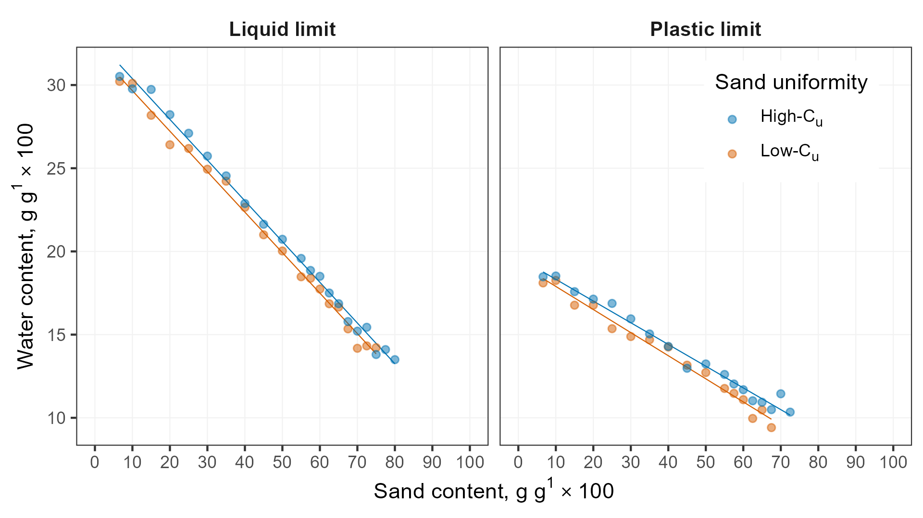

**Figure** : The high-Cu sand had higher LL and PL than the low-Cu sand at nearly all sand contents.

**Table** : Analysis of variance table for each characteristic water content in Experiment 2. Significant effects at α=0.05 in bold.

| Test type | Term | Sum Sq. | Deg. of Fr. | F-Statistic | P-value |
| --- | --- | --- | --- | --- | --- |
| LL | Intercept | 0.4116 | 1 | 24,715.22 | 0.000000000000000000000000000000000000000000000000000112145 |
| LL | % sand | 0.0659 | 1 | 3,954.04 | 0.000000000000000000000000000000000000020821002921278756580 |
| LL | Uniformity | 0.0001 | 1 | 6.00 | 0.019323258290203166459564343426791310776025056838989257812 |
| LL | % sand x Uniformity | 0.0000 | 1 | 0.06 | 0.806468804825675622538483366952277719974517822265625000000 |
| LL | Residuals | 0.0006 | 36 |  |  |
| PL | Intercept | 0.1315 | 1 | 8,914.39 | 0.000000000000000000000000000000000000011066240343971774160 |
| PL | % sand | 0.0137 | 1 | 928.96 | 0.000000000000000000000003945013270752638824372116044258973 |
| PL | Uniformity | 0.0000 | 1 | 1.32 | 0.259521358555031222969944337819470092654228210449218750000 |
| PL | % sand x Uniformity | 0.0000 | 1 | 1.64 | 0.210114221011237778391489428031491115689277648925781250000 |
| PL | Residuals | 0.0004 | 30 |  |  |

### Uniformity effect on [apparent] threshold fines content

A more interesting feature of Experiment 2 was that the mixtures containing different Cu sands became nonplastic at different sand contents. Low-Cu sand mixes containing 70, 72.5, and 75% sand could not be rolled into threads, but high-Cu mixes at these sand contents still had measurable plastic limits. These observations suggest that the threshold fines content is affected by sand uniformity and merits further study. Calculations for the TFC and real soil behavior observed in experiments rarely coincide (Zuo and Baudet, 2015). However, little attention has been paid to soil mixtures containing plastic fines as opposed to nonplastic silt or two granular materials. While not replicated or tested across multiple clay types, this research has demonstrated the potential to accurately compute TFC from the minimum void ratio of a sand without the need to perform time-consuming experiments.

# Conclusions

In Experiment 1, the LL and PL of mixtures containing equivalent sand content but varying uniformity were virtually identical.

In Experiment 2, Low-Cu mixtures had significantly higher LL compared to high-Cu mixtures having equivalent sand content. There was an analogous trend for PL, but the effect was not significant. The higher LL and PL could be due to the higher specific surface area of the high-Cu sand. Mixtures produced with the low-Cu sand became nonplastic at relatively higher sand content. This suggests the threshold fines content (marking a transition between plastic and nonplastic behavior) could potentially be computed from the void ratio of the sand.

Future research could evaluate potential interactions between sand uniformity and the plasticity of the clay. Additional work could investigate mixtures with higher Cu sands and further explore the links between sand Cu, void ratio, and TFC.

# Conflict of interest

The authors declare that there are no conflicts of interest.

# Author contributions

# References

Adams, W.A., and R.J. Gibbs. 1994. Natural Turf for Sport and Amenity. 1st ed. CABI International.

ASTM International. 2011. F1815-11 Standard Test Methods for Saturated Hydraulic Conductivity , Water Retention , Porosity , and Bulk Density of Athletic Field Rootzones. : 1–6. doi: [10.1520/F1815-11.2](https://doi.org/10.1520/F1815-11.2).

ASTM International. 2016. [4253-16: Test Methods for Maximum Index Density and Unit Weight of Soils Using a Vibratory Table](https://doi.org/10.1520/D4253-16). ASTM International.

ASTM International. 2017. [Test Methods for Particle-Size Distribution (Gradation) of Soils Using Sieve Analysis](https://doi.org/10.1520/D6913_D6913M-17). ASTM International.

ASTM International. 2018. D4318-17, Standard Test Methods for Liquid Limit, Plastic Limit, and Plasticity Index of Soils. : 20. doi: [10.1520/D4318-17E01.](https://doi.org/10.1520/D4318-17E01.)

Atterberg, A. 1911. Die Plastizität der Tone. Intern mitt. boden: 4–37.

Baker, B., Stephen W. (Sports Turf Research Institute). 2006. Rootzones, Sands and Top Dressing Materials for Sports Turf. Sports Turf Research Institute, West Yorkshire, England.

Barnes, G.E. 2013. The Plastic Limit and Workability of Soils. <https://www.escholar.manchester.ac.uk/api/datastream?publicationPid=uk-ac-man-scw:212752&datastreamId=FULL-TEXT.PDF>.

Brady, N.C., and R.C. Weil. 2007. The Nature and Properties of Soils. Prentice Hall, Upper Saddle River, NJ.

Dumbleton, M.J., and G. West. 1966. The influence of the coarse fraction on the plastic properties of clay soils- RRL Report No. 36. Road Research Laboratory, Crowthorne, Berkshire.

GNU. 2020. GNU Make. Free Software Foundation.

Hojae, Y., and A.S. McNitt. 2001. [Measurement of bulk mechanical properties of root-zone sand mixtures](https://doi.org/10.13031/2013.4119). 2001 Sacramento, CA July 29-August 1,2001. American Society of Agricultural and Biological Engineers

Holtz, R.D., W.D. Kovacs, and T.C. Sheahan. 2010. An Introduction to Geotechnical Engineering. Pearson, New York, NY.

Krumbein, W.C. 1941. Measurement and Geological Significance of Shape and Roundness of Sedimentary Particles. SEPM JSR Vol. 11. doi: [10.1306/D42690F3-2B26-11D7-8648000102C1865D](https://doi.org/10.1306/D42690F3-2B26-11D7-8648000102C1865D).

Lade, P.V., C.D. Liggio Jr., and J.A. Yamamuro. 1998. Effects of Particle Shapes and Sizes on the Minimum Void Ratios of Sand. Geotechnical Testing Journal 21(4): 336–347.

Miller, N.A., and J.J. Henderson. 2011. Correlating Particle Shape Parameters to Bulk Properties and Load Stress at Two Water Contents. Agron. J. 103(5): 1514–1523. doi: [10.2134/agronj2010.0235](https://doi.org/10.2134/agronj2010.0235).

Mitchell, J.K., and K. Soga. 1993. Fundamentals of Soil Behavior. 3rd ed. Wiley.

Sibley, E.L.D., and C.P. Polito. 2020. [Insights on Threshold Fines Content](https://geovirtual2020.ca/wp-content/files/406.pdf). Geovirtual 2020 Resilience and Innovation

Sivapullaiah, P.V., and A. Sridharan. 1985. Liquid Limit of Soil Mixtures. Geotechnical Testing Journal 8(3): 111–116. doi: [10.1520/gtj10521j](https://doi.org/10.1520/gtj10521j).

Suhr, B., W.A. Skipper, R. Lewis, and K. Six. 2020. Shape analysis of railway ballast stones: Curvature-based calculation of particle angularity. Sci Rep 10(1): 6045. doi: [10.1038/s41598-020-62827-w](https://doi.org/10.1038/s41598-020-62827-w).

Team, R.C. 2022. [R: A language and environment for statistical computing. R Foundation for Statistical Computing](https://www.R-project.org/). Vienna, Austria.

Wadell, H. 1932. Volume, Shape, and Roundness of Rock Particles. The Journal of Geology 40(5): 443–451. <https://www.jstor.org/stable/30058012>.

Zuo, L., and B.A. Baudet. 2015. Determination of the transitional fines content of sand-non plastic fines mixtures. Soils and Foundations 55(1): 213–219. doi: [10.1016/j.sandf.2014.12.017](https://doi.org/10.1016/j.sandf.2014.12.017).